SCII/00825/2019
MICHAEL ORINA
ADVANCED INTERNET AND WEB PROGRAMMING

CAT 2

a) Describe the terms as used in web services

(i)POX ( 1 marks)

Plain Old XML (POX) refers to techniques where applications exchange raw XML documents using standard transfer protocols, such as HTTP, Simple Mail Transfer Protocol (SMTP) and File Transfer Protocol (FTP), or using proprietary protocols (such as message-oriented middleware)

(ii) REST ( 1 marks)

Representational State Transfer(REST) is an architectural style that specifies constraints, such as the uniform interface, that if applied to a web service induce desirable properties, such as performance, scalability, and modifiability, that enable services to work best on the Web

(iii)SOAP ( 1 marks)

SOAP stands for Simple Object Access Protocol. It is a XML-based protocol for accessing web services. SOAP is a W3C recommendation for communication between two applications. . By using SOAP, you will be able to interact with other programming language applications.

b) Describe the term Service Oriented Architecture (SOA) (2 marks)

Service-Oriented Architecture (SOA) is a style of software design where services are provided to the other components by application components, through a communication protocol over a network. Its principles are independent of vendors and other technologies.

c) Explain any FOUR benefits of cloud computing (4 marks)
Whether you experience a natural disaster, power failure or other crisis, having your data stored in the cloud ensures it is backed up and protected in a secure and safe location.

Being able to access your data again quickly allows you to conduct business as usual, minimizing any downtime and loss of productivity.

Security Cloud computing offers great security when any sensitive data has been lost.

Low maintenance cost. Cloud computing reduces both hardware and software maintenance costs for organizations.

d) Describe the term AJAX and explain how it is can be applied it in
web development, stating its advantages ( 5 marks)

Ajax is a set of web development techniques that uses various web technologies on the client-side to create asynchronous web applications

With Ajax, web applications can send and retrieve data from a server asynchronously (in the background) without interfering with the display and behavior of the existing page. By decoupling the data interchange layer from the presentation layer, Ajax allows web pages and, by extension, web applications, to change content dynamically without the need to reload the entire page. In practice, modern implementations commonly utilize JSON instead of XML.

Advantages

- Improved user experience.
- Asynchronous processing.
- Reduced server hits and network load.
- Platform and architecture neutrality.
- Multibrowser support.
- Faster page renders and improved response times.

e) PHP is one of the server side programming languages that you can
use in your web applications. Write a PHP statement that can be used
to:
(iv) Pass data from the PHP script to HTML so as to be viewed
on a browser (1 mark)

<html>
<body>
<form action="welcome_get.php" method="get">
Name: <input type="text" name="name"><br>
E-mail: <input type="text" name="email"><br>
<input type="submit">
</form>
<?php

Welcome echo $_GET["name"]; ?><br>
Your email address is: echo $_GET["email"]; ?>
?>
</body>
</html>

(v)Pass data from HTML element called ‘name’ to PHP
variable called $name in script. (1 mark)

<script>
myPlugin.start($name);
<?php myPlugin.start($name); ?>
myPlugin.start(<?=$name?>);
</script>

(vi) Connect PHP program to MySQL server (2 marks)

<?php
$servername = "localhost";
$username = "username";
$password = "password";
// Create connection
$conn = new mysqli($servername, $username, $password);
// Check connection
if ($conn→connect_error) {
die("Connection failed: " . $conn->connect_error);
}
echo "Connected successfully";
?>

f) Describe the following terms as used in service
deployment/acquisition models in cloud computing (3 marks)

(I) Software as a service (SAAS)

Software-as-a-Service (SaaS) is a software licensing model, which allows access to software a subscription basis using external servers. SaaS allows each user to access programs via the Internet, instead of having to install the software on the user's computer.

(ii) Platform as a service (PAAS)

Platform as a service (PaaS) or application platform as a service (aPaaS) or platform-based service is a category of cloud computing services provision, instantiate, run, and manage a modular bundle comprising a computing platform and one or more applications, without the complexity of building and maintaining the infrastructure typically associated with developing and launching the application

(iii) Infrastructure as a service (IAAS)

Infrastructure as a service are online services that provide high-level APIs used to deferenciate various low-level details of underlying network infrastructure like physical computing resources, location, data partitioning, scaling, security, backup

g) Using a clearly labeled diagram, describe the term Model –View-
Controller (MVC) as used in Internet and Web Programming (4
marks)

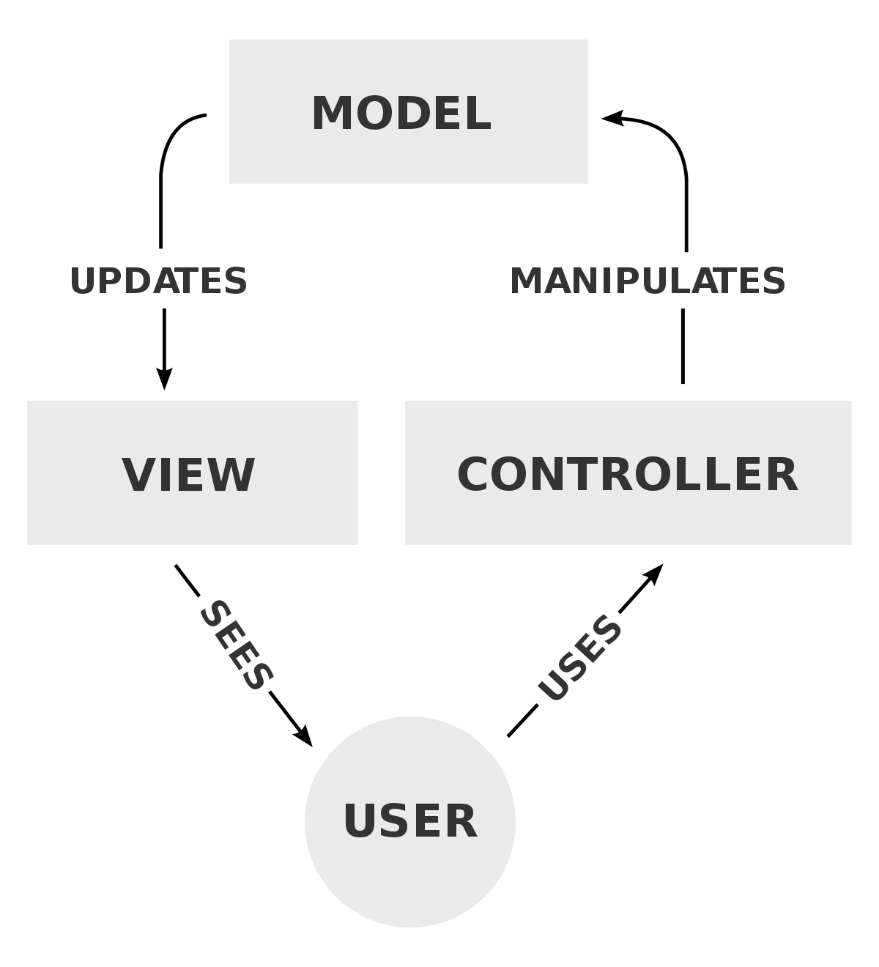

Model–view–controller is a software design pattern commonly used for developing user interfaces that divide the related program logic into three interconnected elements. This is done to separate internal representations of information from the ways information is presented to and accepted from the user

h) Explain how the following trends are influencing the future of web
design and development (5 marks)
(i) noSQL Dbs
Scalability: A fundamental design goal of NoSQL solution is to store unstructured data over a distributed environment, where tables are large and stored separately across nodes. It also aims to provide “unlimited” data capacity for rapidly growing data.

(ii) Easier Hosting, Deployment and Scaling

Affordable web hosting plans, reliable servers, 24/7 support. VPS, reseller, shared hosting, dedicated servers for you.
A successful web application needs to seamlessly and efficiently accommodate growth, and be designed with scalability in mind. A scalable web application will be able to handle an increase in users and load, without disrupting the end users

(iii) No-Touch Interfaces

With a touchless user interface, users can interact with displays without physically touching the surface, significantly reducing the risk of contamination in spaces such as hospital operating theaters and on patient monitoring equipment

(iv) Massively Online users

This increases the market for products that is being developed. It brings more money flow

(v) Internet of Things
The Internet of Things (IoT) describes physical objects that are embedded with sensors, processing ability, software, and other technologies and that connect and exchange data with other devices and systems over the Internet or other communications networks

The Internet of Things is recognized as one of the most important areas of future technologies and is gaining vast recognition in a wide range of applications and fields related to smart cities, military, education, hospitals, homeland security systems, transportation and autonomous connected cars, agriculture

